Soil pollution can be defined as persistent chemicals, salts, toxic compounds, and radioactive materials that adversely affect animal health and plant growth. There are many ways through which soils can get polluted. These are the Discharge of industrial waste into the Earth’s surfaces.



Prevention of soil pollution can be done by (i) the use of manure instead of synthetic fertilizers. (ii) use of natural pesticides. (iii) avoid the dumping of polythene and plastics in soil. (iv) industrial waste should be treated before release in soil.

Water Pollution refers to the presence of impurities and harmful elements in the water. It is a source of many deadly diseases that cause harm, diseases, and even kill human civilization. The polluted water is not fit for drinking and is harmful to live beings such as animals, birds, and human beings.



Prevention of soil pollution can be done by (i) the use of manure instead of synthetic fertilizers. (ii) use of natural pesticides. (iii) avoid the dumping of polythene and plastics in soil. (iv) industrial waste should be treated before release in soil.

Air pollution is a mixture of solid particles and gases in the air. Car emissions, chemicals from factories, dust, pollen, and mold spores may be suspended as particles. Ozone, a gas, is a major part of air pollution in cities. When ozone forms air pollution, it's also called smog. Some air pollutants are poisonous.

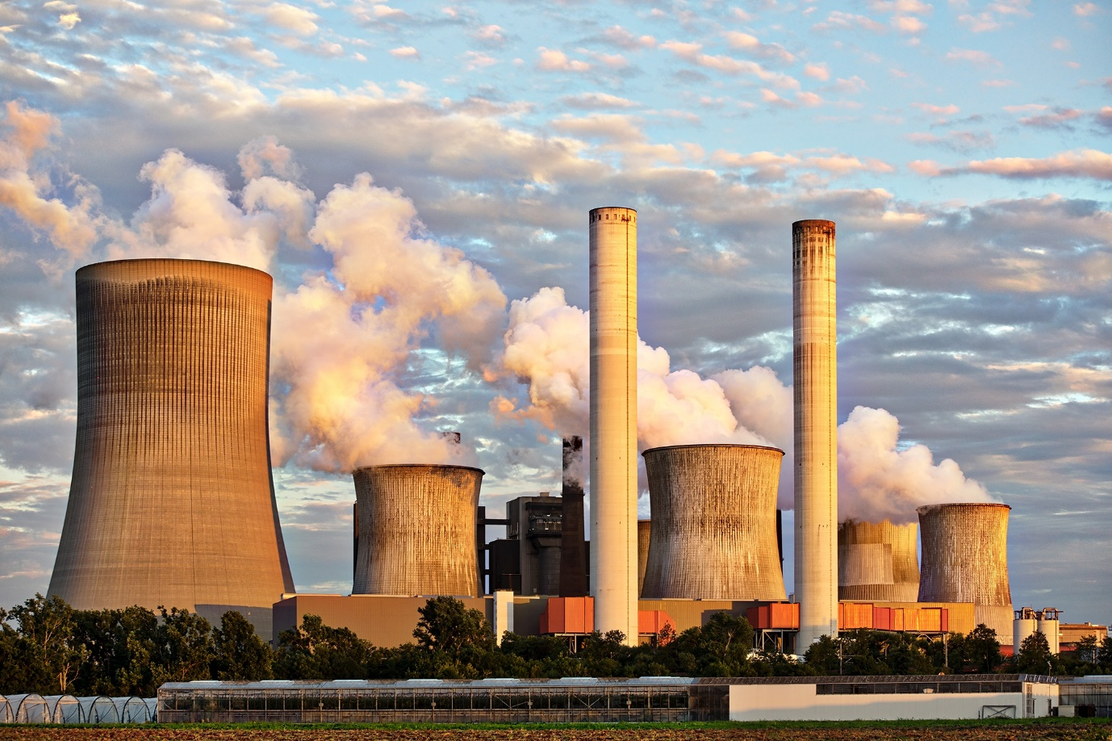

1. Reduce the number of trips you take in your car.

2. Reduce or eliminate fireplace and wood stove use.

3. Avoid burning leaves, trash, and other materials.

4. Avoid using gas-powered lawn and garden equipment.

Nois e pollution is when the level of noise increases more than the normal level. When the amount of noise exceeds, it becomes dangerous for living beings. Moreover, these unpleasant sounds cause several disturbances and create an imbalance in the environment. In other words, high-volume noises are abnormal.

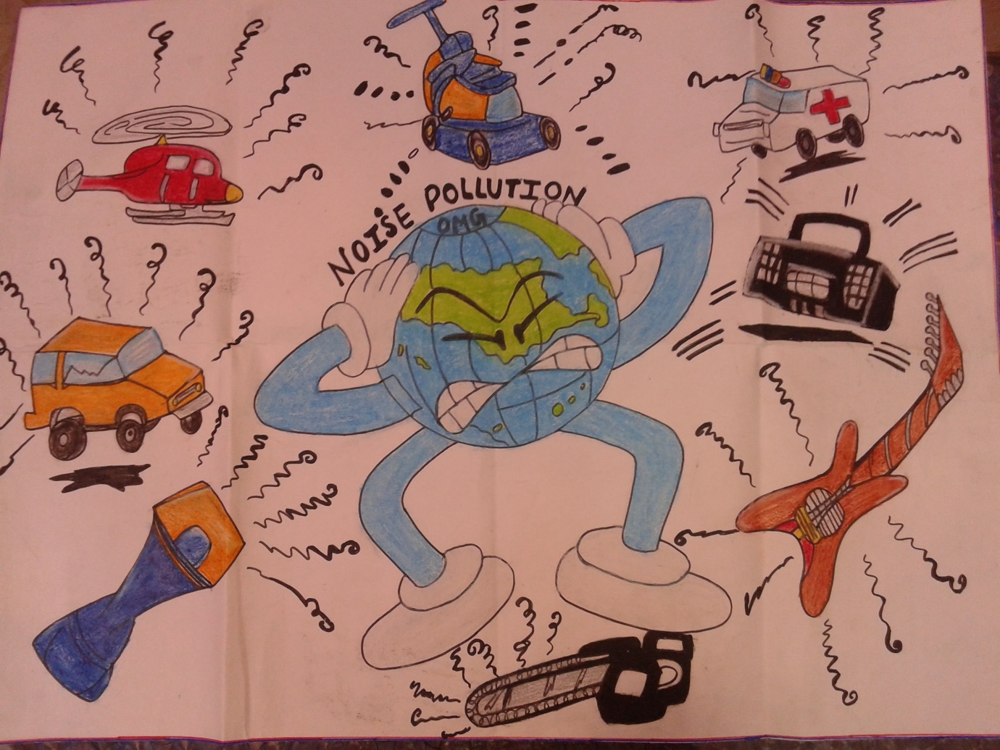

1. Turn off Appliances at Home and offices. ...

2. Shut the Door when using noisy Machines. ...

3. Use Earplugs. ...

4. Lower the volume. ...

5. Stay away from Noisy areas. ...

6. Follow the Limits of the Noise level. ...

7. Control Noise level near sensitive areas. ...

9. Go Green by planting trees